BM-006

TRƯỜNG ĐẠI HỌC VĂN LANG ĐỀ THI KẾT THÚC HỌC PHẦN

CHƯƠNG TRÌNH ĐÀO TẠO ĐẶC BIỆT Học kỳ: 1 Năm học: 2021 - 2022

Mã học phần: 7XH0040 Tên học phần: Community Service-Learning 2

Mã nhóm lớp HP:

Thời gian làm bài:

Hình thức thi:

Two weeks (Questions will be given on 30 October. Students need to submit by 14/November)

Tiểu luận (Reflective journal)

Cách thức nộp bài (Giảng viên ghi rõ):

- Upload file bài làm (word, excel, pdf…)

Giảng viên nộp đề thi, đáp án bao gồm cả Lần 1 và Lần 2 trước ngày 25/10/2021.

Format nội dung:

- Font: Times New Roman

- Size: 13

ĐỀ BÀI:

In your individual reflective essay, please:

- Describe one aspect of the service project that left the deepest impression on you, and explain why. ( 4 points)
(The aspect can be from the way your team solved the challenges or your experience in working with community partner/beneficiary. You need to give more explanation why you choose this experience. You should follow Gibbs model)

- What have you learned from the entire course? (3 points)

( The lessons can be knowledge, skills and attitude that you feel most meaningful.)

- What have you learned about your own ability to act as a responsible leader and as a responsible citizen? (3 points)
( You should link the experiences to your own life. What do you need to do to make the society better? What do you need to do to help disadvantaged people? )

Total: 10 points.

HƯỚNG DẪN SINH VIÊN TRÌNH BÀY:

This assignment covers Course Learning Outcome CLO1-2-3-4-5

- This is an individual assignment.

- The submission format is in the form of a reflective essay.

- The assignment should have a cover page that includes the course code and name, assignment number and tittle, assessors’ names and full name(s) of student(s) and ID.

BM-006

- Ensure that authenticity declaration has been signed.

- Include a content sheet with a list of all headings and page numbers (table of content).

- Plagiarism is unacceptable. Students must cite all sources, and input the information by paraphrasing, summarizing or using direct quotes. A Failed Grade is given when Plagiarism is identified in your work. There are no exceptions.

- Your evidence/findings must be cited using Harvard Referencing Style.

- This assignment should be written in a concise, formal business style using font

Times New Roman, font size 12, and spacing 1.5.

The word limit is 800 words (+/- 10%). If you could not meet the word limit (excluding references and administrative sections) your grade will be deducted.

TIÊU CHÍ CHẤM ĐIỂM: ………………

Assessment rubric


Criterion

8-10

Outstanding

6-7.5

Good

5-5.9

Satisfactory

<5

Inadequate

Content


Linkage of | The student | The student | The student | The student
Academic | demonstrated a | was able to | was able to | was not able to
Content to | thorough | identify the | express some | connect the
Service- | understanding of | major links | connections | academic
Learning | the academic | between the | between the | content with
(20%) | concepts and | academic | academic | his/her
(20%) | correctly | content and | content and | experiences in
 | extrapolated | his/her | the service | the service
 | beyond them. | experiences | experiences. | setting.
 | He/she was able to | and
 | identify the social | observations in
 | issues pertinent to | the service
 | the service project, | setting.
 | apply the
 | academic concepts
 | to analyze their
 | relevance to the

BM-006


project and the

society, and to

develop his/her

own perspective

based on both

theories and

service.

Reflectivenes s

(20%)


The student | The student | The student | The student
demonstrated an | demonstrated | made some | showed no
ability to question | an ability to | attempt to | attempt to
one's | question one's | question one's | question one's
preconceptions, | preconceptions | preconceptions | preconceptions
stereotypes, biases | , stereotypes, | , stereotypes, | , stereotypes,
and/or | biases and/or | biases and/or | biases and/or
assumptions, and | assumptions. | assumptions. | assumptions.
develop a | There was | However, | Mostly stayed
transformed | some evidence | conclusions | on the
personal | of critical self- | reached were | descriptive
perspective. | reflections, | rather | level.
He/she showed a | new insights or | superficial or
highly logical and | understanding. | clichéd some
critical analysis of |  | of the time.
self, others and/or
subject concepts,
and examined the
learning process to
show what
learning occurred,
how it occurred,
and how new
awareness was
acquired.
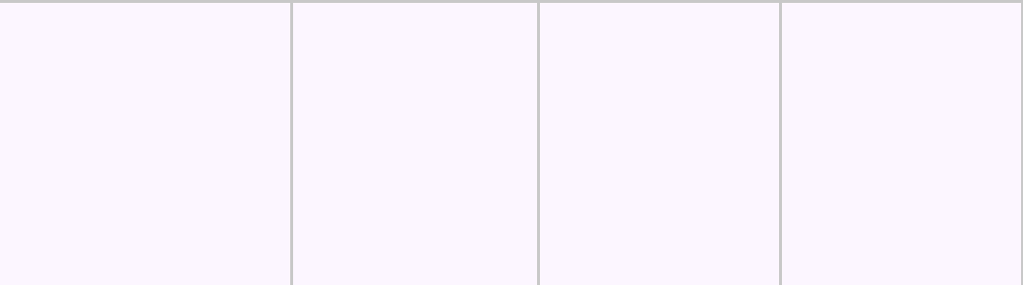

Evidence- | The student used | The student | The student | No examples
based | specific and | used relevant | used some | or poorly
(20%) | convincing | examples from | examples to | formed
(20%) | examples from the | the SL | support claims | examples were



Social

Responsibilit

y

(30%)

 |  |  | BM-006
SL experience to | experience to | in writing. | used to
explain and | support claims | Connections | support claims
support claims in | in writing. | and | in writing. No
writing. He/she | He/she moved | development | or incorrect
moved far beyond | beyond a | were vague or | connections
description to | descriptive | forced. | were made
make insightful | level to make |  | with the
and applicable | applicable |  | academic
connections. | connections. |  | content.


The student | The student | The student | The student
acknowledged that | acknowledged | demonstrated | demonstrated
he/she had a | his/her | an awareness | little
responsibility to | responsibility | of the notion | awareness of
the community, | to the | of personal | personal
and expressed a | community, | responsibility | responsibility
commitment to | and indicated a | to community, | to community
working towards | willingness to | and | and hardly
the betterment of | work towards | acknowledged | gave any
the community, | the betterment | the need for | thought about
and getting other | of the | being involved | it.
people involved. | community. | in service.

Writing/ | Fully effective, | Clear overall | Overall | Overall
Presenting | very clear overall | structure with | structure | structure
(10%) | structure with no | only minor | understandable | incoherent or
(10%) | obvious English | English | , but with | barely
(Structure | mistakes. Coheren | mistakes. | obvious | understandable
(Structure | t within the piece | Coherent | English | . Multiple and
and | of writing and the | within the | mistakes | obvious
Organization | incidents being | piece of | and/or | English
) | described. Used | writing and the | incoherencies. | mistakes
 | appropriate style | incidents being | Style and tone | and/or
 | and tone. | described. | were | incoherencies.
 |  | Used | acceptable. | Used
 |  | appropriate |  | inappropriate
 |  | style and tone. |  | style and tone.

BM-006

Ngày biên soạn: 01/10/2021

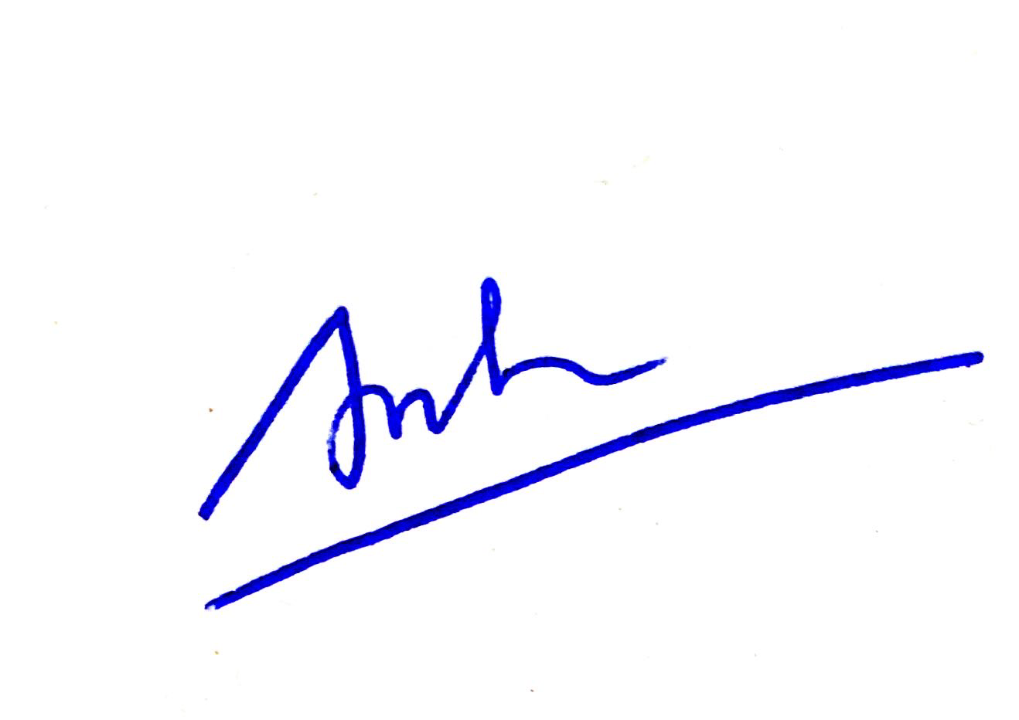
Giảng viên biên soạn đề thi:

Phạm Văn Anh

Ngày kiểm duyệt: 22/10/2021

Trưởng (Phó) Khoa/Bộ môn kiểm duyệt đề thi:

Trưởng Ban PTCTHTQT 


TS. Ngô Quang Trung

Sau khi kiểm duyệt đề thi, Trưởng (Phó) Khoa/Bộ môn gửi về Trung tâm Khảo thí qua email: khaothivanlang@gmail.com bao gồm file word và file pdf.

